 | 13.1.11 Editors - Shader Editor - Header - Add Menu - Vector
Table of content
Detailed table of content 1
Add menu - Vector 3
Bump 3
Displacement 4
Mapping 5
Normal 6
Normal Map 7
Vector Curves 8
Vector Displacement 10
Vector Rotate 11
Vector Transform 11

Detailed table of content
Detailed table of content
Detailed table of content 1
Add menu - Vector 3
Bump 3
Inputs 3
Strength 3
Distance 3
Height 4
Normal 4
Properties 4
Invert 4
Outputs 4
Normal 4
Displacement 4
Inputs 4
Height 4
Mid level 4
Scale 4
Normal 4
Properties 5
Space 5
Outputs 5
Displacement 5
Mapping 5
Inputs 5
Vector 5
Location 5
Rotation 5
Scale 5
Properties 5
Vector type 5
Point 5
Texture 6
Vector 6
Normal 6
Outputs 6
Vector 6
Normal 6
Inputs 6
Normal 6
Properties 7
Normal Direction 7
Outputs 7
Normal 7
Dot 7
Normal Map 7
Inputs 7
Strength 7
Color 7
Properties 7
Space 7
UV Map 8
Outputs 8
Normal 8
Vector Curves 8
Inputs 8
Factor 8
Vector 8
Channel buttons 8
Curve edit field 8
Selecting Points 8
Adding Points 8
Navigation elements 9
Zoom in and out 9
Tools 9
Reset View 9
Vector Handle 9
Auto Handle 9
Auto Clamped Handle 9
Extend horizontal 9
Extend extrapolated 9
Reset Curve 9
Use Clipping 9
Delete Points 9
Outputs 9
Vector 9
Vector Displacement 10
Inputs 10
Vector 10
Mid level 10
Scale 10
Properties 10
Space 10
Outputs 10
Displacement 10
Vector Rotate 11
Inputs 11
Vector 11
Center 11
Axis 11
Angle 11
Properties 11
Type 11
Invert 11
Outputs 11
Vector 11
Vector Transform 11
Inputs 11
Vector Input 11
Properties 12
Type 12
Convert From 12
Convert To 12
Outputs 12
Vector Output 12

Add menu - Vector
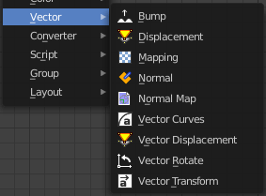
Here you find nodes that deals with vector data.

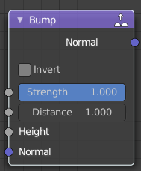
Bump
The Bump node generates a perturbed normal from a height texture, for bump mapping. The height value will be sampled at the shading point and two nearby points on the surface to determine the local direction of the normal.

Inputs

Strength
Strength of the bump mapping effect, interpolating between no bump mapping and full bump mapping.

Distance
Multiplier for the height value to control the overall distance for bump mapping.

Height
Scalar value giving the height offset from the surface at the shading point; this is where you plug in textures.

Normal
Standard normal input.

Properties

Invert
Invert the bump mapping, to displace into the surface instead of out.

Outputs

Normal
Standard normal output.

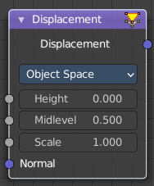
Displacement
The Displacement node is used to displace the surface along all the surface normal, to add more detail to the geometry. Both procedural textures and baked displacement maps may be used.
For best results the mesh must be subdivided finely to bring out the detail in the displacement texture.
It is also possible to use the displacement as bump mapping only by changing the material settings, so that no high resolution mesh is needed.

Inputs

Height
Distance to displace the surface along the normal. This is where a texture node can be connected.

Mid level
Neutral displacement value that causes no displacement. With the default 0.5, any lower values will cause the surfaces to be pushed inwards, and any higher values will push them outwards.

Scale
Increase or decrease the amount of displacement.

Normal
Standard normal input.

Properties

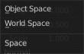
Space
Object Space means the displacement scales along with the object. When using World Space the object scale is ignored.

Outputs

Displacement
Displacement offset to be connected into the Material Output.

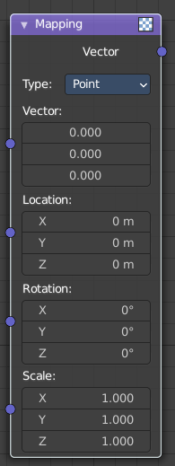
Mapping
The Mapping node transforms the input vector by applying translation, rotation, and scaling.

Inputs
The inputs of the node are dynamic. In particular, the Location input is only available in the Texture and Point vector types.

Vector
The vector to be transformed.

Location
The amount of translation along each axis.

Rotation
The amount of rotation along each axis. XYZ order.

Scale
The amount of scaling along each axis.

Properties

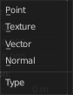
Vector type
The node applies the transformation differently depending on the semantic type of the input vector.

Point
For this vector type, the node performs a straightforward transformation.
Transforming a texture coordinates is analogous to transforming a UV map. For instance, translating the texture coordinates along the positive X axis would result in the evaluated texture to move in the negative X axis, much like if one translated a UV map. Similarly, scaling the texture coordinates up would result in the evaluated texture to scale down. So transforming the texture coordinates would appear to have the opposite effect on the evaluated texture.
The order of transformation is: Scale –> Rotate –> Translate, which means:
Translation moves the input along the local rotation axis.
Rotation rotates the input around the origin of the space.
Scaling scales the input along the global axis.

Texture
For this vector type, the node performs an inverse transformation.
Inverse transforming a texture coordinates would, as opposed to the Point type, transform the evaluated texture itself. For instance, translating the texture coordinates along the positive X axis would result in the evaluated texture to move in the positive X axis, as one would expected. Similarly, scaling the texture coordinates up would result in the evaluated texture to scale up, as one would expect.
The order of transformation is: Translate –> Rotate –> Scale, which means:
Translation moves the input along the global axis.
Rotation rotates the input around the translation vector.
Scaling scales the input along the local rotation axis.

Vector
For this vector type, a Point transformation is performed, but with zero translation.

Normal
For this vector type, the node performs the inverse transpose of the transformation and normalize the result. Such transformation ensures correct normals after non-uniform scaling. So this type should be used when transforming normals.

Outputs

Vector
The input vector after transformation.

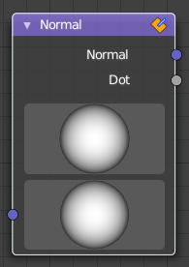
Normal
The Normal node generates a normal vector and a dot product.

Inputs

Normal
Normal vector input.

Properties

Normal Direction
To manually set a fixed normal direction vector. LMB click and drag on the sphere to set the direction of the normal. Holding Ctrl while dragging snaps to 45 degree rotation increments.

Outputs

Normal
Normal vector output.

Dot
Dot product output. The dot product is a scalar value.
If two normals are pointing in the same direction the dot product is 1.
If they are perpendicular the dot product is zero (0).
If they are anti parallel (facing directly away from each other) the dot product is -1.

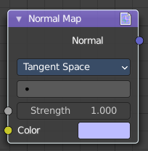
Normal Map
The Normal Map node generates a perturbed normal from an RGB normal map image. This is usually chained with an Image Texture node in the color input, to specify the normal map image. For tangent space normal maps, the UV coordinates for the image must match, and the image texture should be set to Non-Color mode to give correct results.

Inputs

Strength
Strength of the normal mapping effect.

Color
RGB color that encodes the normal in the specified space.

Properties

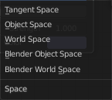
Space
The input RGB color can be in one of three spaces: Tangent, Object and World space. Tangent space normal maps are the most common, as they support object transformation and mesh deformations. Object space normal maps keep sticking to the surface under object transformations, while World normal maps do not.

UV Map
Name of the UV map to derive normal mapping tangents from. When chained with an Image Texture node, this UV map should be the same as the UV map used to map the texture.

Outputs

Normal
Normal that can be used as an input to BSDF nodes.

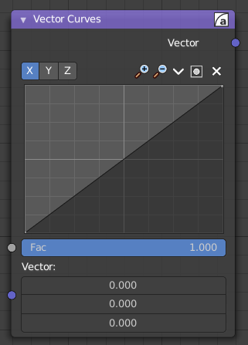
Vector Curves
The Vector Curves node maps an input vector components to a curve.

Inputs
In the shader context the node also has an additional Factor property.

Factor
Controls the amount of influence the node exerts on the output vector.

Vector
Standard vector input.
Properties
Channel

Channel buttons
X, Y, Z. Clicking on one of the channels displays the curve for each.

Curve edit field
Create and tweak a Bezier curve that varies the input levels (X axis) to produce an output level (Y axis).


Selecting Points
You can select curve points. This reveals two edit boxes for the x and y coordinate of this point.
Selected points can be moved around. Left click at them, hold the mouse button down and move them to a new location.


Adding Points
You can add new curve points by simply left clicking at the curve. Move the mouse to position them where you need it.

Navigation elements
The navigation elements at the top are described from left to right.

Zoom in and out
The two buttons with the magnifying glass at it zooms in and out in the curve window.

Tools

Tools is a menu where you can find some curve related tools.

Reset View
Resets the curve windows zoom.

Vector Handle
Set handle type to Vector.

Auto Handle
Set handle type to Auto.

Auto Clamped Handle
Set handle type to Auto Clamped.

Extend horizontal
Extends the curve before the first curve point and behind the last curve point horizontally.

Extend extrapolated
Extends the curve before the first curve point and behind the last curve point extrapolated.

Reset Curve
Resets the curve to the initial shape.


Use Clipping
Clipping options. Set up clipping for the stroke.

Delete Points
Deletes selected curve points.

Outputs

Vector
Standard vector output.

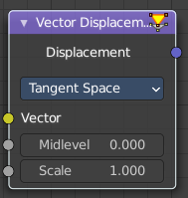
Vector Displacement
The Vector Displacement node is used to displace the surface along arbitrary directions, unlike the regular Displacement node which only displaces along the surface normal.
It is typically used to apply vector displacement maps created by other sculpting software. Vector displacement maps can fully represent the high resolution detail to be applied on a smooth base mesh, unlike regular displacement maps.
For best results the mesh must be subdivided finely to bring out the detail in the displacement texture.

Inputs

Vector
Vector specifying the displacement along three axes. This is where a texture node can be connected.
Typically a baked vector displacement image texture is used. For Object Space, RGB colors in the image are interpreted as an XYZ offset in object space. For Tangent Space, R is an offset along the tangent, G along the normal and B along the bi tangent.

Mid level
Neutral displacement value that causes no displacement. With the default 0.0, any lower values will cause the surfaces to be pushed inwards, and any higher values will push them outwards.

Scale
Increase or decrease the amount of displacement.

Properties

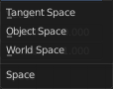
Space
Object Space maps work for static meshes, and will render slightly faster with less memory usage. Tangent Space maps can be used for meshes that will be deformed, like animated characters, so the displacement follows the deformation.

Outputs

Displacement
Displacement offset to be connected into the Material Output.

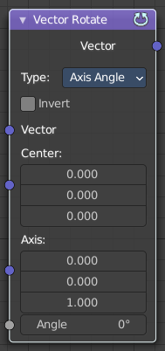
Vector Rotate
This node provides the ability to rotate a vector around a center point using either Axis Angle, Single Axis or Euler methods.

Inputs

Vector
The input vector.

Center
The center for the rotation.

Axis
The axis angles.

Angle
The rotation angle.

Properties

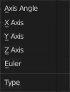
Type
The rotation type.

Invert
Invert the angle

Outputs

Vector
The output vector

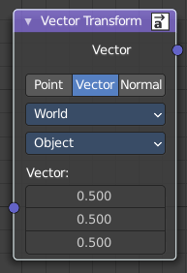
Vector Transform
The Vector Transform node allows converting a vector, point, or normal between world and camera and object coordinate space.

Inputs

Vector Input
Standard vector input.

Properties

Type
Specifies the input/output type.
Vector, Point, Normal.

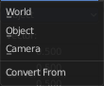
Convert From
Coordinate Space to convert from World, Object or Camera.

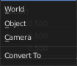
Convert To
Coordinate Space to convert to World, Object or Camera.

Outputs

Vector Output
The transformed output vector.

